PROBLEM STATEMENT

Creating a Tic Tac Toe game setup in python which basically means building a interactive console game.

OBJECTIVE

The primary objective is to create a fully functional Tic Tac Toe game using Python. This project focuses on building an interactive and user-friendly game that allows two players to compete. It also aims to demonstrate programming concepts such as control structures, input handling, and basic game logic.

OUTCOME

The completion of the Tic-Tac-Toe project successfully delivered a fully functional, interactive two-player game built using Python. This outcome validated the core programming objectives, including the implementation of essential game logic such as board state representation (using a 3x3 matrix), robust player turn management, and accurate input handling. Crucially, the project's logic successfully incorporates the complex win-condition algorithm to detect horizontal, vertical, and diagonal victories, as well as the condition for a "Draw" or "Cat's Game" when the board is full.

REQUIREMENT ANALYSIS

We require:
- Python
- Microsoft Windows 10 Home Single Language
- Version 10.0.19045 Build 19045
- System Model Inspiron 5570
- System Type x64-based PC
- System SKU 0810
- Processor Intel(R) Core(TM) i5-8250U CPU @ 1.60GHz, 1800 Mhz, 4 Core(s), 8 Logical Processor(s)
- BIOS Version/Date Dell Inc. 1.14.0, 06-04-2023
- SMBIOS Version 3.0
- Embedded Controller Version 255.255

PROBLEM DEFINITION

TIC TAC TOE - Develop a Python program that enables two players to play the classic game of Tic Tac Toe on a 3x3 grid. The game should allow each player (one as 'X' and the other as 'O') to take turns entering their moves. The system must validate each move, update the board, and display the current state after each turn. The program should automatically check for winning conditions (three matching symbols in a row, column, or diagonal) or a draw (if the board is full with no winner), and announce the result accordingly. Input validation and error handling for invalid or duplicate moves are required to ensure smooth gameplay.

ALGORITHM

Step1: Start.

Step 2: Initialize Game
  - Create a 3x3 board with empty cells.
  - Set the starting player as 'X'.
Step 3: Repeat Until Game Ends
  - Print the current state of the board.
  - Get valid move input (row, column) from the current player.
  - Place the player’s symbol at the chosen cell.
  - Check for winner:
  - If the current player has filled a row, column, or diagonal, declare them as the winner and end the game.
  - If no winner, check for draw:
  - If all cells are filled and no winner, declare a draw and end the game.
  - If game still ongoing, switch to the other player ('X' ↔ 'O').

Step 4: Game Ends
  - Announce the winner or draw, and display the final state of the board.​
This algorithm concisely maps your program logic and follows standard Tic Tac Toe gameplay structure.

Step 5: Stop.

WORKFLOW DIAGRAM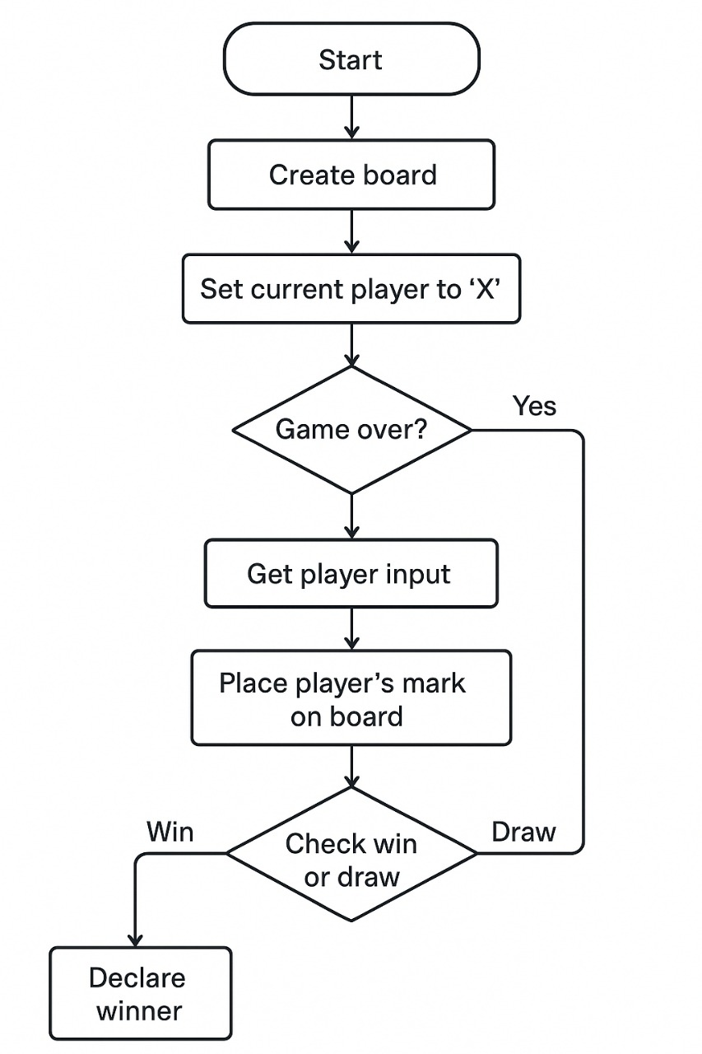

IMPLEMENTATION

Code:
def create_board():

return [
[' ', ' ', ' '],
[' ', ' ', ' '],
[' ', ' ', ' ']
]

def print_board(board):
print("\n 0 1 2")
for i, row in enumerate(board):

print(f"{i} " + " | ".join(row))
if i < 2:
print(" ---|---|---")
print()

def check_win(board, player):
for r in range(3):
if all(board[r][c] == player for c in range(3)):
return True

for c in range(3):
if all(board[r][c] == player for r in range(3)):
return True

if all(board[i][i] == player for i in range(3)):
return True

if all(board[i][2 - i] == player for i in range(3)):
return True

return False

def check_draw(board):

for r in range(3):
for c in range(3):
if board[r][c] == ' ':
return False

return True

def get_player_input(player, board):

while True:
user_input = input(f"Player '{player}', enter move (row col): ")
parts = user_input.split()

if len(parts) != 2:
print("Invalid input. Please enter TWO numbers separated by a space.")
continue

row_str, col_str = parts

if not (row_str.isdigit() and col_str.isdigit()):
print("Invalid input. Please enter NUMBERS for row and col.")
continue

row = int(row_str)
col = int(col_str)

if not (0 <= row <= 2 and 0 <= col <= 2):
print("Coordinates out of range. Must be 0, 1, or 2.")
continue

if board[row][col] != ' ':
print("That cell is already taken! Try again.")
continue

return row, col

def play_game():

print("--- Welcome to Tic-Tac-Toe! ---")

board = create_board()
current_player = 'X'
game_over = False

while not game_over:

print_board(board)

row, col = get_player_input(current_player, board)

board[row][col] = current_player

if check_win(board, current_player):
print_board(board)
print(f"🎉 Player '{current_player}' wins! Congratulations!")
game_over = True

elif check_draw(board):
print_board(board)
print("It's a draw! 🤝")
game_over = True

else:
current_player = 'O' if current_player == 'X' else 'X'

if __name__ == "__main__":
play_game()

TESTING APPROACH

1. Unit Testing:
- Board Initialization:
Verify that a new board is correctly created, typically as an empty 3x3 grid.
- Making a Move:
Test placing markers (X or O) at specific positions on the board and ensure the board state updates correctly. Handle invalid moves (e.g., placing on an already occupied cell or outside the board boundaries).
- Checking for Winner:
Implement tests for all possible winning conditions (rows, columns, and diagonals) for both players.
- Checking for Draw:
Verify that the game correctly identifies a draw when all cells are filled and no winner is found.
- Game State Management:
Test functions that determine if the game is over, if it's a draw, or if a winner exists.
2. Integration Testing:
- Player Interaction:
If the game involves human players or AI components, test the interaction between the game logic and player input/AI decisions.
- Game Flow:
Simulate a complete game from start to finish, including various scenarios like a win for X, a win for O, and a draw.
3. Functional Testing:
- User Interface (if applicable):
If there's a graphical interface, test that it accurately reflects the game state and responds correctly to user input.
- Gameplay Scenarios:
Manually play through different game scenarios to ensure the game behaves as expected under various conditions (e.g., first player wins, second player wins, specific winning patterns, blocking moves).

RESULTS
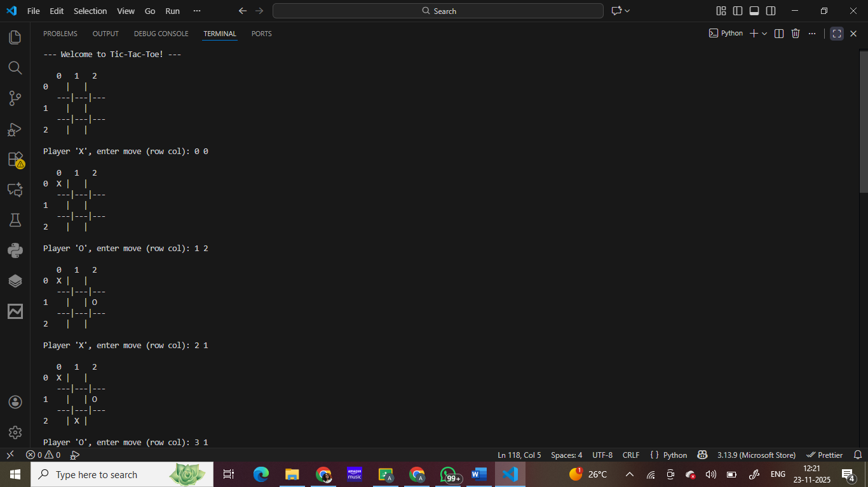
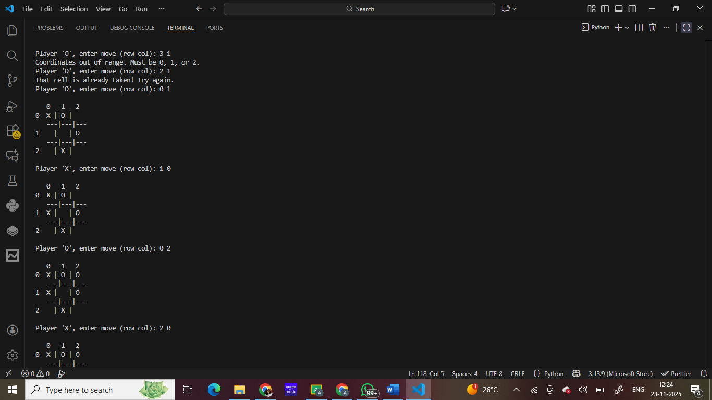
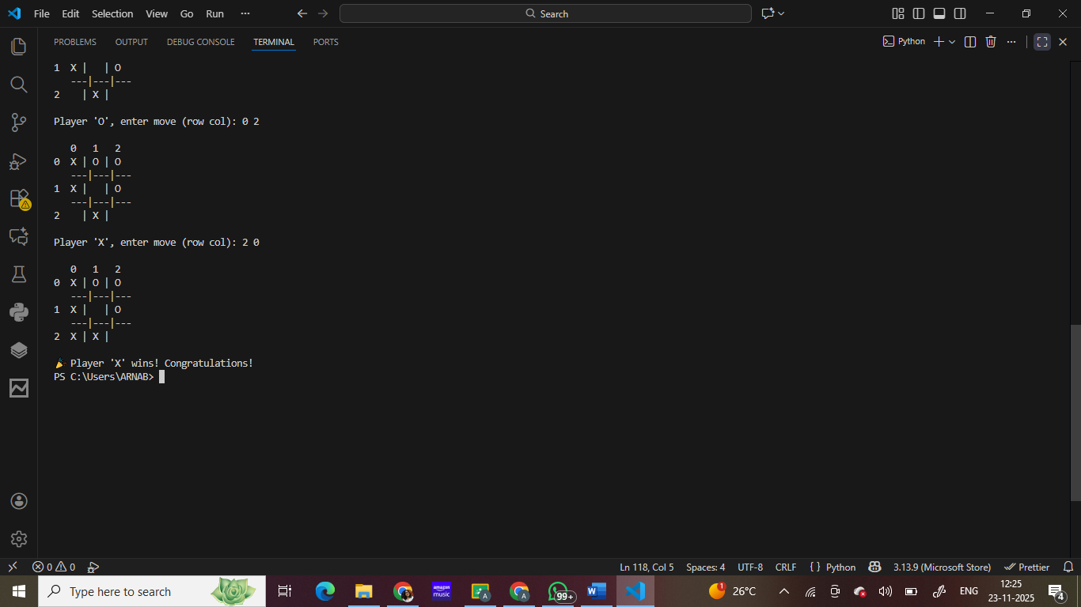

CHALLENGES FACED

While developing the Tic-Tac-Toe game in Python, several challenges were encountered throughout the process. One major challenge was designing the game board using nested lists and ensuring that each move updated the correct position without causing indexing errors. Handling user input also required careful validation to check whether the entered values were numeric, within range, and not already occupied. Implementing the win-checking logic was another difficulty, as it involved checking rows, columns, and both diagonals accurately using loops and conditions. Additionally, managing the overall game flow—switching players, detecting draws, and preventing infinite loops—required a clear understanding of control structures. These challenges helped reinforce concepts such as loops, conditionals, functions, and data validation, ultimately resulting in a functional and user-friendly.

